Material Tower Management

Panasonic Software Systems

CIM Software Development Team

PFSA-CIM

|  |  |
| --- | --- |
|  | **Panasonic System Solutions Company of North America – Process Automation**  1701 Golf Road, Suite 3-1200  Rolling Meadows, IL 60008  Phone: 1-847-637-9600  [www.panasonicfa.com](http://www.panasonicfa.com) |

© Copyright 2019 Panasonic System Solution Company of North America – Process Automation. All rights reserved. Changes may be made without notice to specifications and appearance for product improvement.

**Table of Contents**

Material Tower Management 1

1 Overview 3

2 Adding Material Towers in MC and Gen2 4

2.1 Adding Material Tower in MC 4

2.2 Adding Material Tower in Gen2 9

3 Material Tower Configurations 12

3.1 MyData Tower 12

3.2 Inovaxe Data Tower 18

3.3 Essemtec Tower 22

4 PanaCIM Material Tower Operations 23

4.1 Overview 23

4.2 PanaCIM MC Material Tower Operations 24

4.2.1 Reel Detail Request from Tower 24

4.2.2 Reel Check-in to Tower 25

4.2.3 Reel Check-out from Tower 26

4.2.4 Provide Material from Tower 27

4.3 PanaCIM Gen2 Material Operations – Kitting and Material Verification 29

# Overview

Intelligent material towers are the hardware storage devices that store inventory for production in the SMT manufacturing industry. These storage towers fulfil material requirement while production and ensures seamless production of product. Customers can use storage towers as a complete material control solution in the SMT manufacturing process.

Support for intelligent storage towers has been added in PanaCIM MC 10.7.0.0 release. The application MC supports following storage towers.

* MyData Tower
* Inovaxe Tower
* Essemtec Tower

The Communication Hub application is used as a communication bridge between PanaCIM EE Gen2, MC application, and storage towers. The Communication Hub application must be installed and configured in order to establish proper communication. For Inovaxe and MyData storage towers, Communication Hub configurations are applicable. For Essemtec towers, Communication Hub configurations are not applicable. The Web service URL (Web Service by Tower Vendor) is directly configured using the tower UI for Essemtec storage towers.

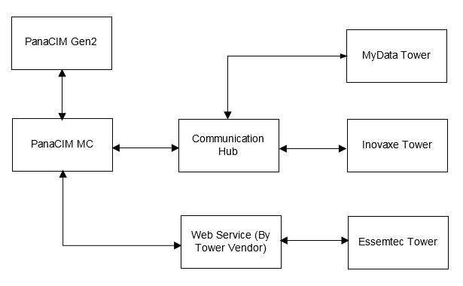

**Note:** For detailed steps to install Communication Hub application, refer the PanaCIM EE Gen2 Service Manual.

Following important points need to be noted regarding this functionality:

* PanaCIM MC acts as a data master source containing the material barcodes of all reels that are stored in intelligent storage towers.
* Tower name (storage unit name) added in MC application must match the physical storage tower name.
* MC license is required to storage towers. Tower specific licensing is not implemented as of now.

# Adding Material Towers in MC and Gen2

Material towers can be created in MC and PanaCIM EE Gen2. Refer the below subsections to created storage material towers.

## Adding Material Tower in MC

The MC application provides user interface to create storage tower locations. All supported vendors’ storage towers (MyData, Inovaxe, and Essemtec) can be created in MC application. The name of a storage tower in MC application must be same as the name of the physical storage tower.

Refer the below action table to add material storage towers in MC application.

|  |  |  |
| --- | --- | --- |
| **Step** | **Description** | **Screenshot** |
| 1 | Login to MC application. |  |
| 2 | Select **MC Config 🡪 Part config**. |  |
| 3 | Select the **Location** tab. |  |
| 4 | The **Create a Location** page appears. |  |
| 5 | Enter storage tower name and select **Location Type** as **Intelligent Material Tower** from the dropdown. |  |
| **Note:** | Storage tower name must be same as the physical storage tower name. | |
| 6 | Select **Unload Location** and **Area** from the respective dropdowns. |  |
| 7 | Provide storage tower description and specify TSM settings as **Degenerative**. |  |
| 8 | Specify **Location Options** as required. |  |
| 9 | Specify physical storage tower settings.  Select type of tower from the **Vendor** dropdown.  The available vendor options are:   * Essemtec * Inovaxe * MyData |  |
| 10 | Enter the IP address and port number of the windows machine where storage tower web service (from vendor) is hosted.  In case of MyData and Inovaxe towers, no need to provide IP address and port number.  For Essemtec tower, provide IP address and port number. |  |
| **Note:** | The IP address and port are applicable for Essemtec storage towers only. | |
| 12 | After providing all the required details, click the **Save** button to create the storage tower. |  |
| 13 | The storage tower is created and listed under **Location**. |  |

## Adding Material Tower in Gen2

Refer the below steps to add material storage towers in PanaCIM Gen2.

|  |  |  |
| --- | --- | --- |
| **Step** | **Description** | **Screenshot** |
| 1 | Tap on Line on the scanner. |  |
| 2 | In the line view, tap on C:\Users\saahil.sharma\Documents\PanaCIM 10 Documentation Work\Scanner-Icons\Images\equipment.png icon to configure new equipment. |  |
| 3 | Tap  icon to navigate Storage Tower equipment. |  |
| 4 | Select Storage Tower and drag in the Ancillary Equipment box on left |  |
| 5 | Screen to enter the Material Tower details appears. |  |
| 6 | Enter the material tower details like Name, Barcode, IP Address, and Port number.  Tap on  icon to open the list of supported towers. |  |
| 7 | Select the connected Material Tower.  In this case, MyData is selected.  Tap **OK** to save the configurations. |  |
| 8 | The Material Tower is listed in the Ancillary Equipment list in the Line View.  Tap **OK** to save the configurations. |  |
| 9 | Tap on **Yes** to apply the changes. |  |

# Material Tower Configurations

**Note:** To create material storage towers in MC application, refer the **Creating Material Tower in MC** section.

Refers the below subsections for configurations required to establish communication between MC and storage towers.

## MyData Tower

The table describes the Communication Hub configurations for MyData storage tower.

|  |  |  |
| --- | --- | --- |
| **Step** | **Description** | **Screenshot** |
| 1 | Login to Communication Hub application. |  |
| 2 | The home page of Communication Hub appears.  Click the **Rule Configuration** tab. |  |
| 3 | The **Rule Configuration** page appears.  Select **MyDataTowerRule** in right pane. |  |
| 4 | The **MyDataTowerRule** page appears. |  |
| **Note:** | By default, the **MyDataTowerRule** rule is not enabled. | |
| 5 | Select the log level from the dropdown. |  |
| 6 | Check the **Enable** check box.  Click the **Save** button. |  |
| 7 | The saved successfully message appears. |  |
| 8 | Click the **Input Parameters** tab. |  |
| 9 | The **Input Parameters** page appears. |  |
|  | 1. **OrderFilePath**: Refers the path of network shared folder, where a work order file is created for the tower. Every time when a material is received by MC, a notification file is created at this location. The storage tower watches this location for files / notifications.   The operator needs to make sure that PanaCIM Communication Hub service has the full access of these MyData tower shared locations.   1. **WaitForAnsInSeconds**: Refers wait timeout in case an answer file is required from tower (when PanaCIM EE Gen2 or MC requests material on demand for kitting). 2. **StorageID**: Refers the tower name configured, this value should be same as the name of tower configured in PanaCIM MC. 3. **ReelBarcodePreFix**: Refers reel barcode prefix. When material is registered in MC, This prefix is added, and updated material barcode with prefix is sent to MyData storage tower. 4. **CarrierPreFix :** Refer the Tray Box prefix. PanaCIM MC appends this prefix when Tray Box detail is sent to MyData storage tower. | |
| 10 | Click the **Queue Adaptors** tab. |  |
| 11 | The **Queue Adaptor** page appears. |  |
|  | 1. **MyTower_REQ**: Refers material provide/kit request sent by PanaCIM EE Gen2 or PanaCIM MC. In response, data tower provides the material response file. 2. **MyTower_REG_REQ**: Sends a notification when a reel is registered in MC, the message is broadcast by the panacim.elink.materialregistratrion queue\topic name. and material’s detail is sent to tower in the form of a file. The tower registers material details in MyData storage tower. 3. **MyTower_Carrier_REQ:** When a reel is move to Tray Box, the  panacim.tower.mat_carrier_req notification received from MC rule creates file for tower and the tower registers material’s detail with Tray Box in MyData storage tower. | |
| 12 | Open the **File Adaptor** tab.  The **C:\temp\tower\NTF** shared folder is a location where the tower puts all files when material is checked-in to the tower or checked-out from tower.  The PanaCIM Communication Hub service should have full access to this location. |  |
| 13 | Click the **Save** button.  The **Saved Successfully** message appears. |  |
| 14 | Click the **Publish** button.  The **Published Successfully** message appears. |  |
| 15 | Once the rule is published, the **MyDataTower** rule appears on the **Home** page of Communication Hub application. |  |

## Inovaxe Data Tower

Inovaxe tower supports plugin based configuration. Refer the below steps to for Inovaxe storage tower Communication Hub configurations.

|  |  |  |
| --- | --- | --- |
| **Step** | **Description** | **Screenshot** |
| 1 | Login to Communication Hub application. |  |
| 2 | Click the **Plugin Configuration** tab. |  |
| 3 | The **Plugin Configuration** page appears.  Select the **InnovaxServiceRule** under the **Plugin Configuration**. |  |
| 4 | The **Inovaxe Service Rule** page appears.  The **Endpoint** field shows Communication Hub application URL and the port number 7201 is fixed.  The Inovaxe storage tower sends message to this URL. |  |
| 5 | Select the log level from the dropdown. |  |
| 6 | Check the **Enable** check box. |  |
| 7 | Select the **Input Parameters** tab. | 1. **StorageID**: This field refers the Inovaxe storage tower name. The name should be same as configured in MC application. If there are multiple storage towers, the tower name will be separated by comma character (,). 2. **ClientWebServiceUrl**: This field refers Inovaxe tower IP address and 9051 is port number. If there are multiple towers, the IP addresses of towers are separated by comma (,) character. |
| 8 | 1. **panacim.tower.mat_storage_req**: This topic sends request to Inovaxe tower to provide reel. 2. **panacim.tower.mat_detail_rsp**: This topic sends reel details from MC to Inovaxe storage tower. |  |
| 9 | Click the **Save** button.  The saved successfully message appears. |  |
| 10 | Click the **Publish** button to publish the rule.  The published successfully message appears. |  |

## Essemtec Tower

The user needs to configure Web service location in the Essemtec storage tower in order to establish communication with PanaCIM MC.

Refer the below steps to configure Essemtec tower to communicate with PanaCIM MC.

|  |  |  |
| --- | --- | --- |
| **Step** | **Description** | **Screenshot** |
| 1 | Open the **eStorage** application running on the PC communicating with the storage tower. Click the **System** button at the bottom. | |
| 2 | Click **Paths & Backup** to see **Notification endpoint / Port** at the bottom.  Click **Edit** to input/update **Notification endpoint / Port** : Provide PanaCIM MC server IP address where the **MCEssServicesHost** window service is installed. The port **1668** is fixed, do not change it.  Click **Save** to save the changes. |  |

# PanaCIM Material Tower Operations

To perform storage tower operations, the user needs to ensure that Communication Hub is installed and configured properly.

Once the MC application is installed, the highlighted services must be visible and running to establish communication between storage towers and MC application.

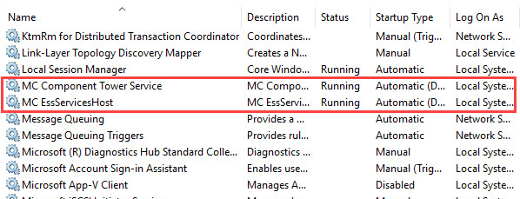

## Overview

Storage tower operations can be initiated from MC and PanaCIM Gen2. The below table lists material tower operations initiated from MC and PanaCIM Gen2 and their support for respective towers.

|  |  |  |  |
| --- | --- | --- | --- |
| **Storage Tower Functions – Material Control / PanaCIM Gen2** | **Inovaxe** | **Essemtec** | **MyData** |
| Reel Detail Request from The Tower –  MC Inventory | Yes | Yes | NA |
| Reel Check-In To Tower Notification  – MC Material Location Update | Yes | Yes | Yes |
| Reel Check-Out From Tower Notification –MC Material Location Update | Yes | Yes | Yes |
| Provide Material from Tower – MC Desktop | Yes | Yes | Yes |
| Provide Material from Tower – Gen2 Material Kitting Scanner | Yes | NA | Yes |
| Provide Material from Tower – Gen2 Verification scanner | Yes | NA | Yes |

## PanaCIM MC Material Tower Operations

The section describes material tower operations that are initiated from Material Control application.

### Reel Detail Request from Tower

Whenmaterial is registered using MC application, a notification is sent to storage tower to notify tower about the material details.

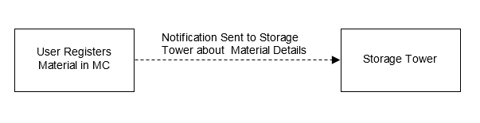

|  |  |  |
| --- | --- | --- |
| **Step** | **Description** | **Screenshot** |
| 1 | Register material using MC application.  A notification is sent to storage tower to notify about material details. |  |

### Reel Check-in to Tower

This refers to storing materials in a storage tower. When a material is checked-in to a storage tower, the MC application receives a notification and updates the location of material to storage tower.

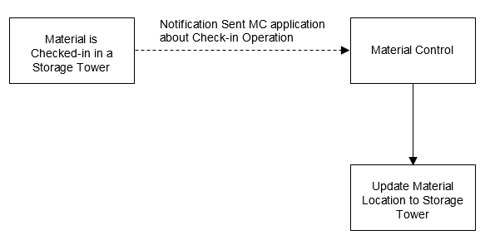

|  |  |  |
| --- | --- | --- |
| **Step** | **Description** | **Screenshot** |
| 1 | When a material is checked-in to a storage tower, the MC application receives a notification and updates the material’s location to the storage tower.  This operation is supported for all towers. |  |

### Reel Check-out from Tower

This refers to taking materials out from a storage tower. When a material is checked-out from a tower, the MC application receives a notification and updates the location of material to the unload location.

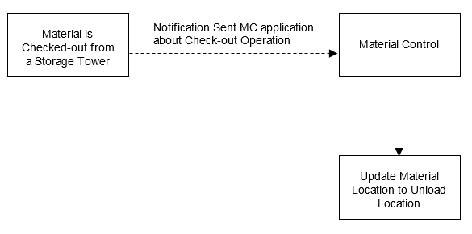

|  |  |  |
| --- | --- | --- |
| **Step** | **Description** | **Screenshot** |
| 1 | When a material is checked-out from a storage tower, the MC application receives a notification and updates the material’s location to the unload location.  This operation is supported for all towers. |  |

### Provide Material from Tower

This refers to checking out materials from storage tower and providing for production. This operation is useful when a work order is running into production and a reel or multiple reels have low part count. In this case, PanaCIM Gen2 requests reel to MC, then the MC application checks-out required reels from storage tower and provide for production to fulfil low part count request.

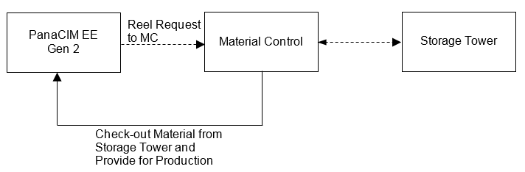

|  |  |  |
| --- | --- | --- |
| **Step** | **Description** | **Screenshot** |
| 1 | Select a material that has been checked-in to a storage tower and click the **Provide** button on MC dashboard.  When the user clicks the **Provide** button, a message is sent to tower to check out material and display the result.  This operation is supported for all towers from MC. |  |
| **Note:** | PanaCIM EE Gen2 also supports this in form of kitting but only for Inovaxe and MyData storage towers. | |
| 2 | The **Provide** option is also supported for multiple materials using cart.  Add multiple materials in cart which exist in a storage tower.  Click the cart icon. |  |
| 3 | Click the **Provide** button. |  |
| 4 | This provides multiple materials from a storage tower.  This is supported for all towers from MC. |  |

**Note:** The provide functionality works for multiple towers at once .i.e. using the provide function, the operator can check-out reals from multiple towers and provide for production simultaneously. For Example:

* I add material 1001 in cart which is in MyData storage tower.
* I add material 1002 in cart which is in Inovaxe storage tower.
* I add material 1003 in cart which is in Essemtec storage tower.
* Click the **Provide** button, all three materials are added in the cart and checked out.

## PanaCIM Gen2 Material Operations – Kitting and Material Verification

Kitting refers picking material for producing the product and placing it into storage units. These storage units are then moved into production zones for the reels to be loaded to feeders.

Following table shows the process of requesting reels from material tower so that these reels can be made available to work orders. Material kitting ensures that reels are checked out from storage tower and reserved for the work order.

If a material is available in non-material tower location (non-intelligent material location), then that material will not be considered in the material kitting list.

|  |  |  |
| --- | --- | --- |
| **Step** | **Description** | **Screenshot** |
| 1 | Tap **Kitting** on PanaCIM EE Gen2 scanner. |  |
| 2 | Select the table for kitting. |  |
| 3 | Tap on the product for which kitting is required. |  |
| 4 | Tap on the setup for which kitting is required |  |
| 5 | Select the part and enter the board quantity.  Tap the **Provide** button to check out material from storage tower. |  |
| **Note:** | The Inovaxe and MyData storage towers support kitting for PanaCIM EE Gen2. | |